Accessibility Boost: Alt Text

What?
Alternative text, commonly called “Alt Text”, is a hidden description of an image. It is read by screen readers or displayed on the screen when an image fails to load.

Why?
The purpose of alternative text is to describe the important parts of an image to ensure that blind, low-vision, and other learners unable to visually access the image receive an equitable experience and don’t miss key information.

Where?
Alternative text should be applied to images in documents, presentation slides, course sites, or any other locations that contain visual information.

How?
Alt Text should be concise and contextual.

Concise
Describe only the relevant information in the image.
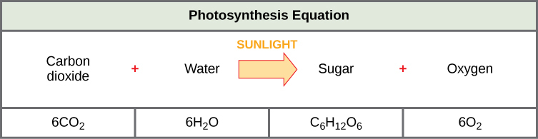
Image from Concepts of Biology - 1st Canadian Edition by Charles Molnar and Jane Gair
A concise description helps highlight the important information in the image: “The photosynthesis equation shows that six carbon dioxide molecules and six water molecules produce one sugar molecule and one oxygen molecule. The sugar molecule is made of 6 carbons, 12 hydrogens, and 6 oxygens. Sunlight is used as an energy source.”

Contextual
Describe the aspects of the image that are important to the specific context in which you’re using it
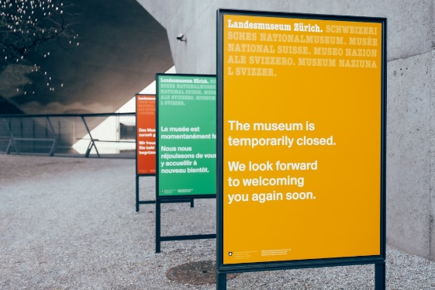
In an article about the underfunding of museums, the alt text might be “A sign stating that the museum is temporarily closed”.
In a presentation about multi-lingual heritage sites, the alt text might be “A row of three signs that read ‘The museum is temporarily closed. We look forward to welcoming you again soon’ in English, French and German.”
Photo by Patrick Robert Doyle on Unsplash

Do
- Include important text that appears in the image in the alt text description
- Use inclusive language in your descriptions (see guide below)
- Mark decorative images as “Decorative” in the alt text menu
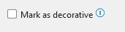

Don’t
- Start descriptions with “Image of…” or “Picture of…”
- Describe images that are purely decorative
- Repeat information that appears elsewhere in the content
- Editorialize or include your own feelings or opinions about the image

More resources
- How to add Alt Text to MS Word and PowerPoint provides steps on how to add alt text to images in different versions of Word and PowerPoint.
- Writing Alt Text for Data Visualization provides guidelines on writing alt text for charts, graphs, and other data visualizations
- A Guide for Inclusive Language is a comprehensive guide to language for describing people in an inclusive way.

